BRACT’s
Vishwakarma Institute of Technology, Pune
Practical Implementation Sheet
Department: CSE-AI Semester: 5 Academic Year: 2026-27
Division: E Batch: 1 Practical No: 3
Roll no: 42 PRN No: 12414728 Name of Student: Saachi Laturiya
Subject Name : Deep Learning

Problem Statement : Implement forward propagation and backpropagation using TensorFlow/Keras. Analyze the effect of different learning rates and the number of epochs on model performance.
Algorithm :
- Import the required Python libraries for data handling, preprocessing, visualization, deep learning, and performance evaluation.
- Load the Breast Cancer Wisconsin dataset from the Scikit-learn library.
- Separate the dataset into input features (X) and target labels (y).
- Split the dataset into training and testing sets.
- Standardize the training and testing data using StandardScaler.
- Create a Multilayer Perceptron (MLP) model using TensorFlow/Keras.
- Compile the model using the Adam optimizer, binary cross-entropy loss function, and accuracy as the evaluation metric.
- Train the model using different learning rates (0.1, 0.01, and 0.001) while keeping the number of epochs constant.
- Evaluate the accuracy obtained for each learning rate and visualize the comparison.
- Train the model using different numbers of epochs (10, 50, and 100) while keeping the learning rate constant.
- Compare the model accuracy for different epoch values using a graph.
- Select the best learning rate and epoch combination to train the final MLP model.
- Predict the class labels for the testing dataset.
- Evaluate the final model using accuracy, confusion matrix, and classification report.
- Visualize the training accuracy, training loss, and confusion matrix to analyze the model performance.
Code :
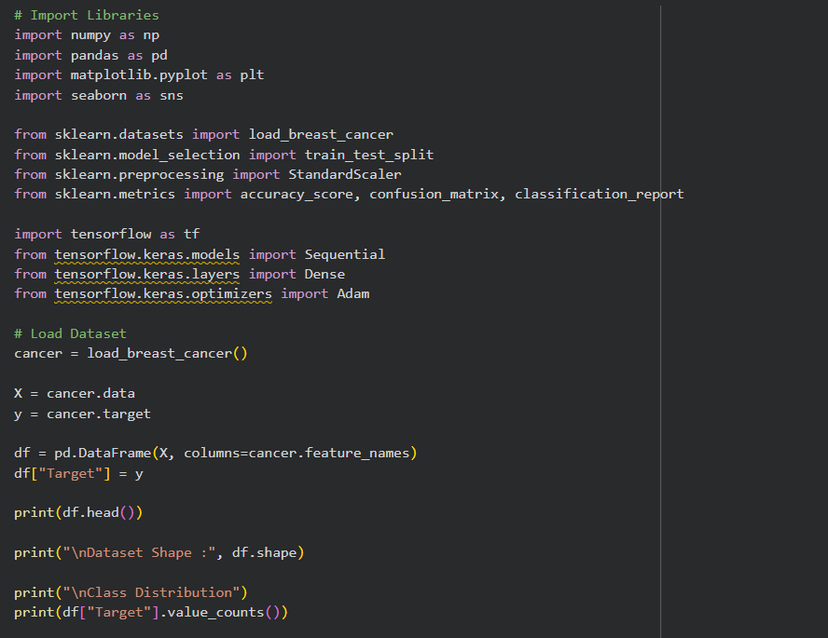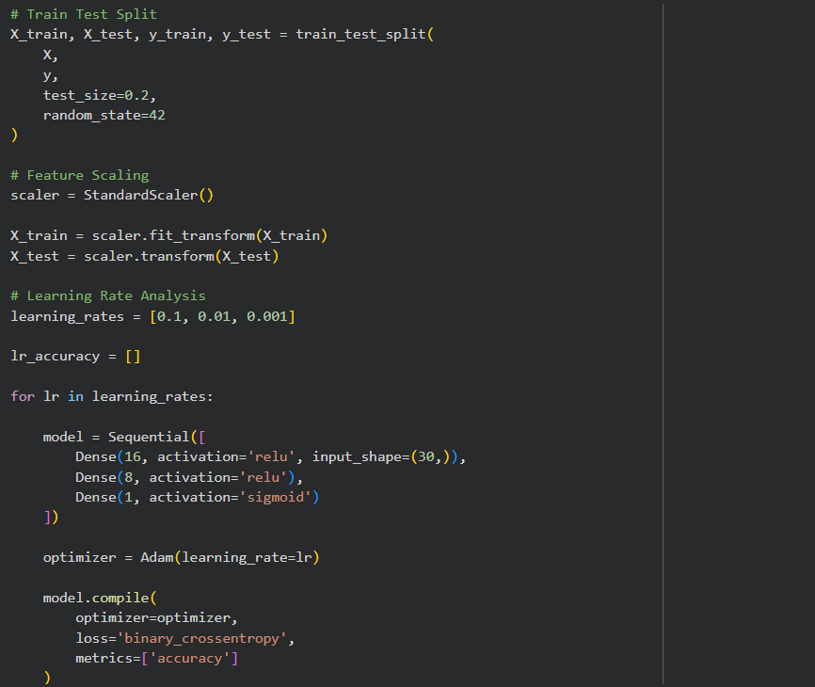
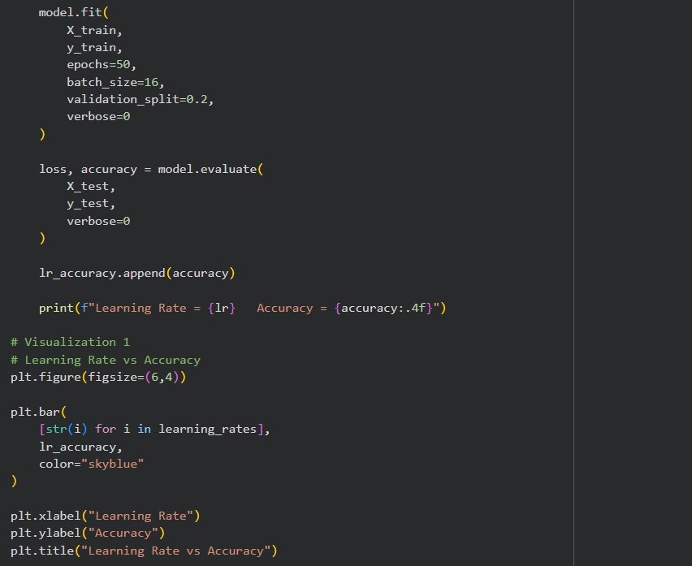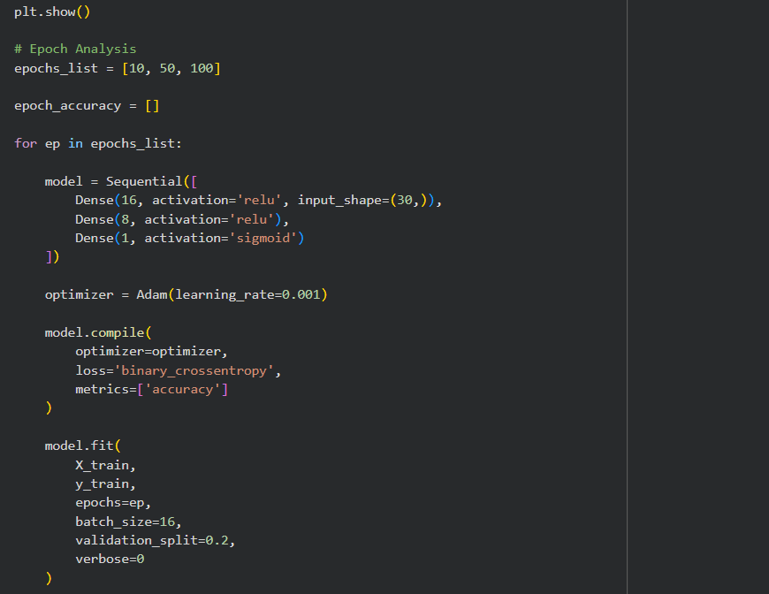
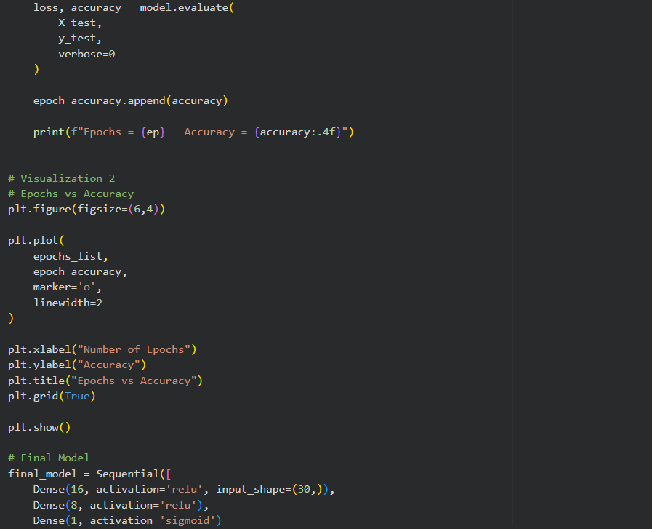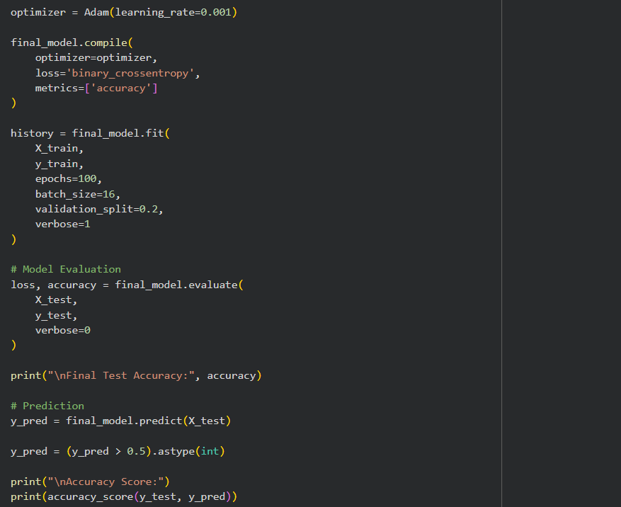
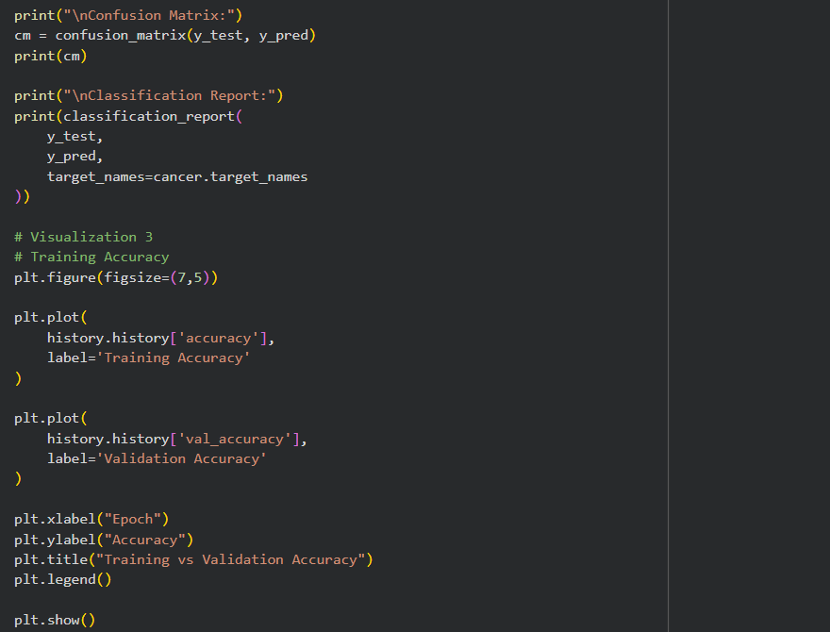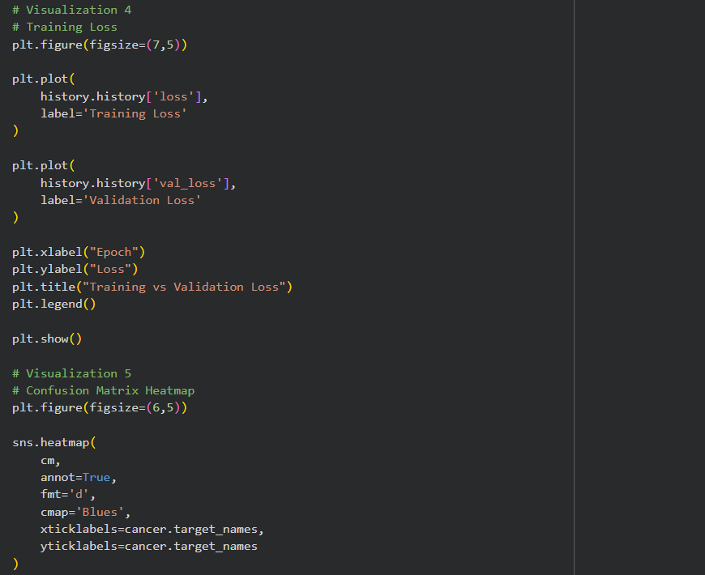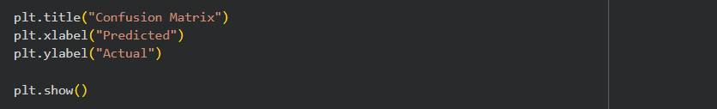
Output :
1. Breast Cancer Wisconsin dataset preview, dataset dimensions, and class distribution.
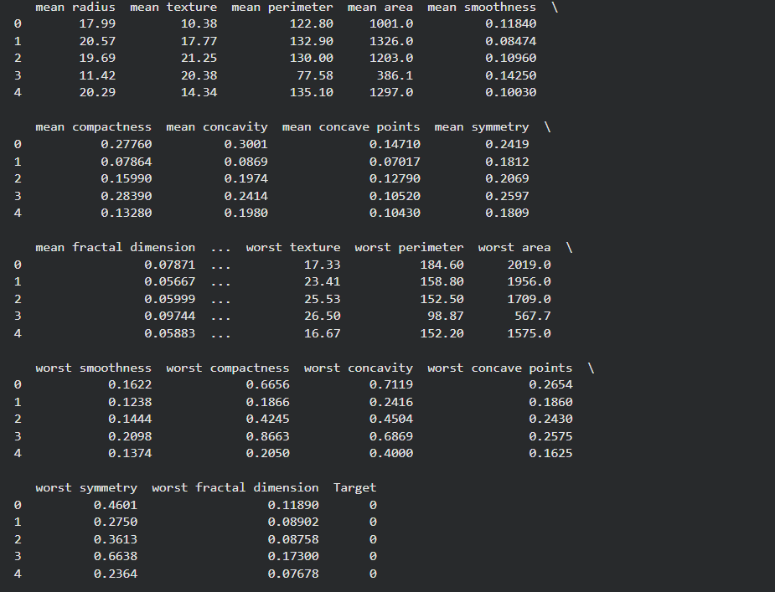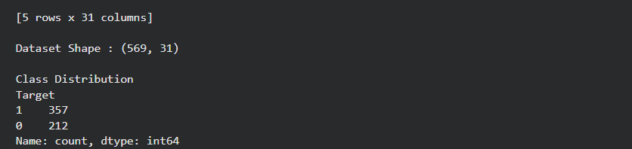

2. Effect of different learning rates on the accuracy of the MLP model.
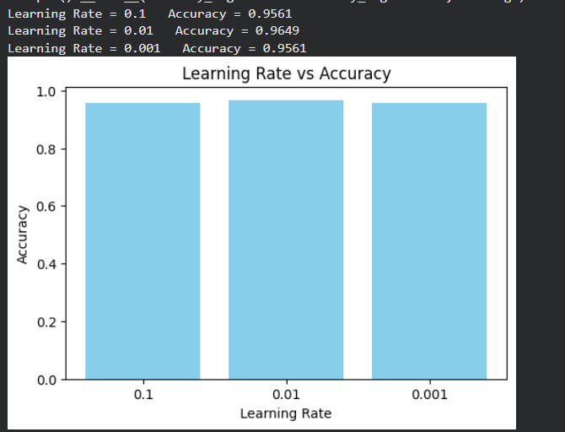
3. Effect of different numbers of epochs on the accuracy of the MLP model.
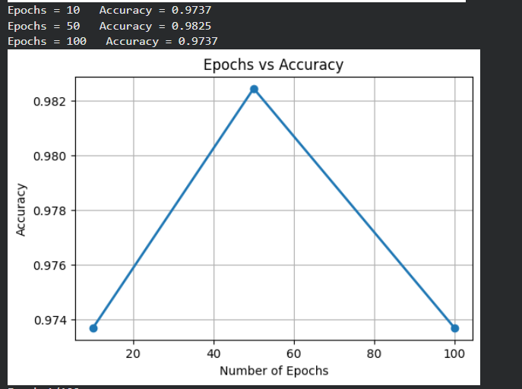

4. Performance evaluation of the trained MLP model showing accuracy, confusion matrix, and classification report.
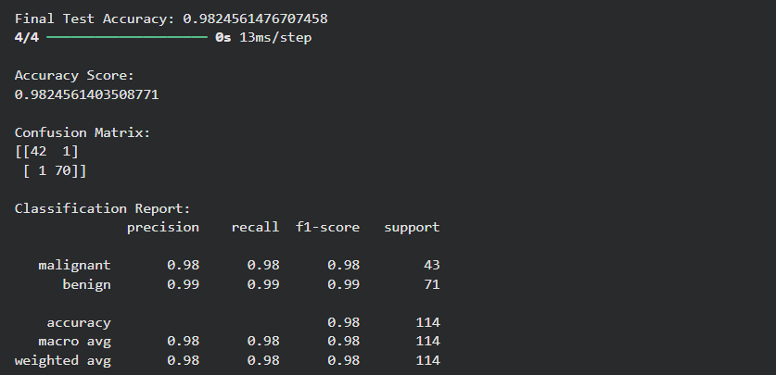
5. Training and validation accuracy of the MLP model over different epochs.
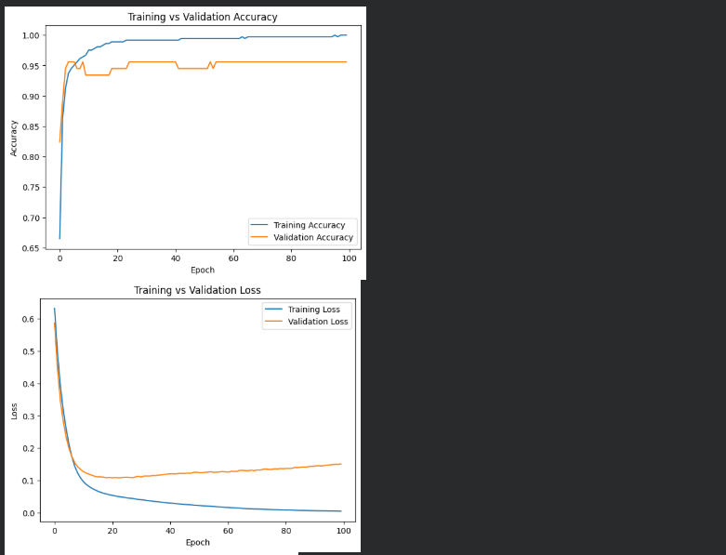
Training and validation loss of the MLP model over different epochs.
6. Confusion Matrix Heatmap
